Herve TCHIENKIO

NWIT-105

Prof. Rob DENSOCK

September 24, 2024

1. **Create a Windows instance using custom options and settings**

**Discussion Topic: Security Groups**

1. An AWS Security Group is a virtual firewall that controls inbound and outbound traffic to AWS resources like EC2 instances by defining rules based on protocols, ports, and IP addresses. It is stateful, meaning responses to allowed traffic are automatically permitted, and only "allow" rules can be set, ensuring controlled access to resources.
2. AWS Security Groups differ from traditional firewalls in that they are stateful, meaning they automatically allow return traffic for established connections without needing explicit outbound rules, while traditional firewalls may require separate rules for inbound and outbound traffic. Additionally, Security Groups operate at the instance level within AWS, providing granular control over specific resources, whereas traditional firewalls typically operate at the network perimeter, protecting entire subnets or networks.
3. AWS Security Groups are similar to host-based firewalls in that they both control traffic at the instance (or host) level, allowing for granular security configurations specific to individual resources. Like host-based firewalls, Security Groups allow administrators to define rules for both inbound and outbound traffic based on protocols, ports, and IP addresses. Additionally, both are designed to protect individual resources rather than an entire network, providing a more localized form of security.
4. Yes, AWS Security Groups can be assigned to one or more instances. This allows you to manage security settings efficiently by applying the same set of rules across multiple instances, ensuring consistent security policies without needing to configure each instance individually. Multiple security groups can also be attached to a single instance for added flexibility in defining access control.
5. **Lab: Create a Security Group and apply it to an instance**

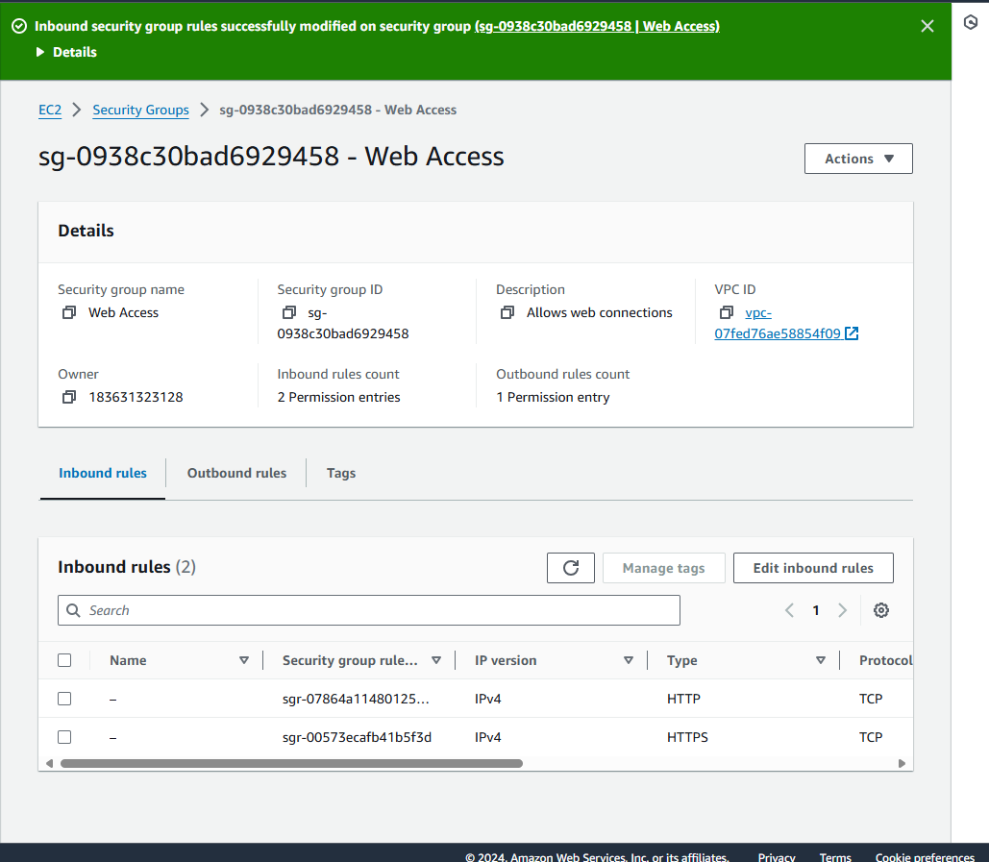

**Screenshot of the Web Access security group page showing HTTP and HTTPS rules**

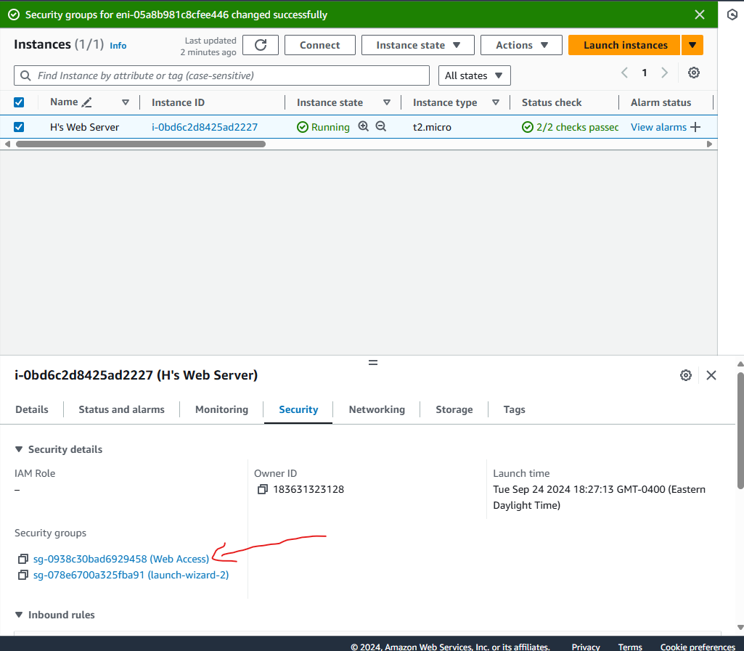

**Screenshot of the Security Tab**